Experiment-2
Program:
import cv2
# Read image
img = cv2.imread("image.jpg")
# Apply Gaussian Blur
blur = cv2.GaussianBlur(img, (15, 15), 0)
# Display images
cv2.imshow("Original Image", img)
cv2.imshow("Blurred Image", blur)
cv2.waitKey(0)
cv2.destroyAllWindows()
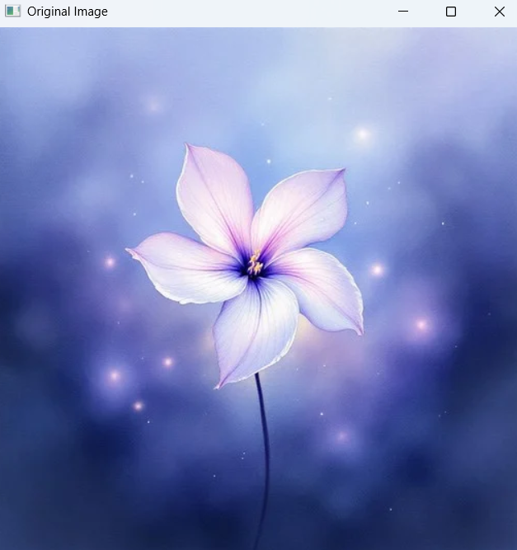
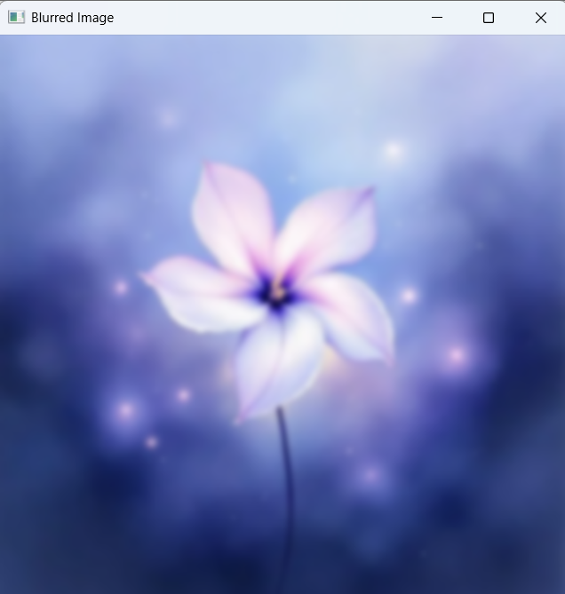
Input: Output:

